SIMATS ENGINEERING (SAVEETHA SCHOOL OF ENGINEERING)
Department of Computer Science and Engineering
ASSESSMENT TOOL 1 – CONCEPT MAP

Course Code: | ITA03 | Course Title: | Mobile computing
CO Assessed: | CO1 | Assessment: | Assessment Tool 1 – Concept Map
Weightage: | 60 % of CIA | Total Marks: | 20 marks
CO1 Statement: | Analyse the mobile network components, mobile base station, mobile infrastructures and protocols in cellular systems.
Student Name: | Boopathi D.C | Reg. No.: | 192511320
Section / Batch: | B.E.CSE | Date: | 12/10/2026

Code of Conduct

I boopathi D.C(192511320) (Name / Reg. No) certify that this submission is my original work and that I have adhered to the guidelines specified for this assessment. I understand that any violation of academic integrity rules will result in disciplinary action.
Signature of the Student: D.C.Boopathi

Instructions
- This test contains ONE question.
- Duration: 30 minutes (At home)

Annexure A - QUESTIONS
- Design a concept map that evaluates the role of the core network in delivering mobile communication services.
Relate authentication, mobility management, subscriber databases, and call routing.
Determine the most influential core network functions.
Justify your evaluation through concept linkages.

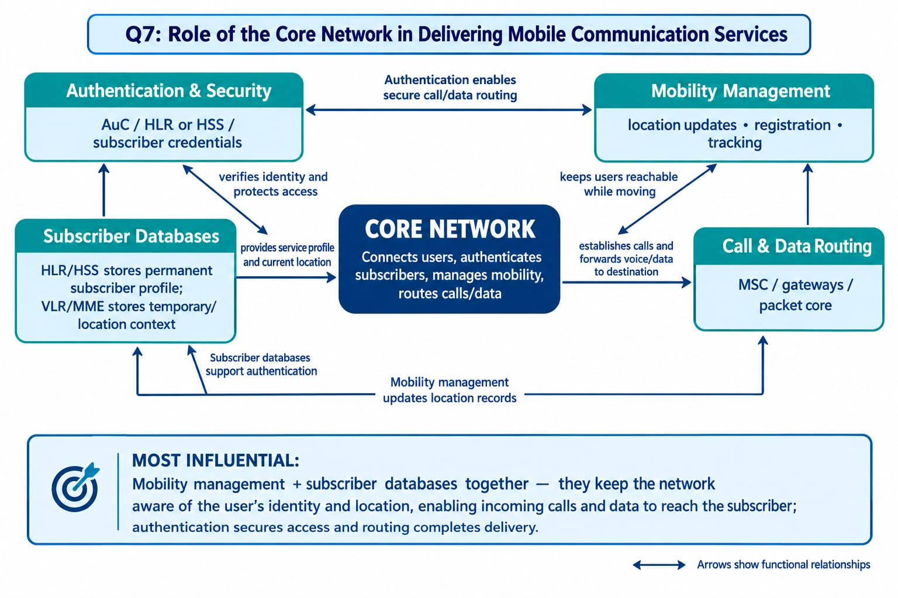

Rubrics for Calculation

Criteria | Weightage | Level 4 – Exemplary | Level 3 – Proficient | Level 2 – Developing | Level 1 – Beginning
Understanding of Problem Context | 20 | Clearly understands the problem and accurately identifies all requirements | Good understanding with minor gaps | Basic understanding; some requirements unclear | Poor understanding or misinterpretation of the problem
Application of Concepts | 30 | Accurately applies appropriate concepts to solve complex problems | Applies relevant concepts correctly with minor errors | Applies basic concepts with limited accuracy | Fails to apply appropriate concepts
Problem-Solving Approach | 20 | Logical, well-structured, and efficient approach | Mostly logical approach with minor gaps | Basic approach with some inconsistencies | Illogical or unclear approach
Accuracy of Solution | 20 | Completely correct solution with proper justification | Mostly correct with minor errors | Partially correct solution | Incorrect or incomplete solution
Clarity | 10 | Clear, well-organized, and properly explained solution | Understandable with minor clarity issues | Limited clarity and explanation | Poorly presented and difficult to understand

Faculty In-charge | Course Coordinator | Program Director
Signature: _______________ | Signature: _______________ | Signature: _______________
Date: ___________________ | Date: ___________________ | Date: ___________________

